Using Avro serialization/deserialization for Kafka Producer/Consumer the following log show message transmition via Kafka:

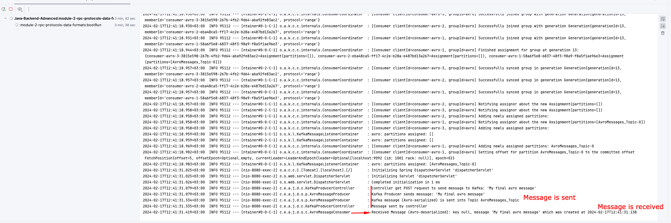

Offset Explorer depicts all transmitted messages in serialized representation in a topic:

